Inernet Explorer Setting for ePayroll

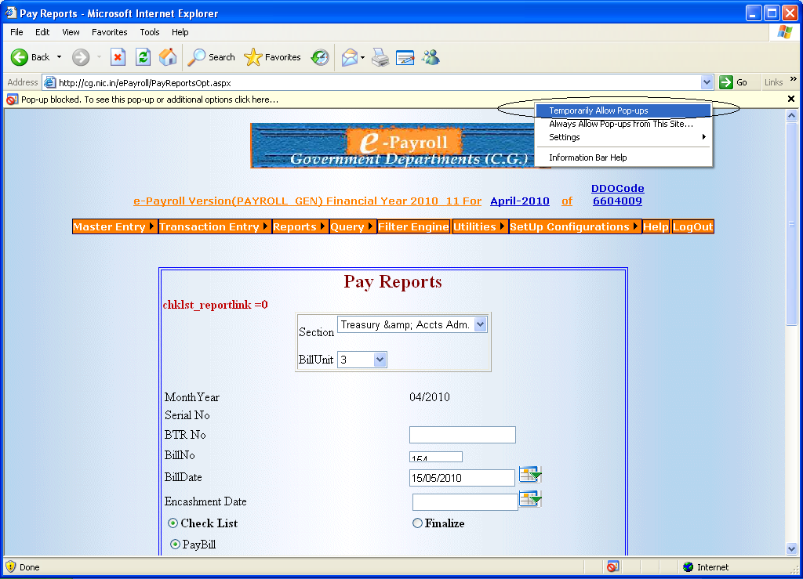
If Pop-up is blocked .Then Temporally Allow Pop-up for this site.
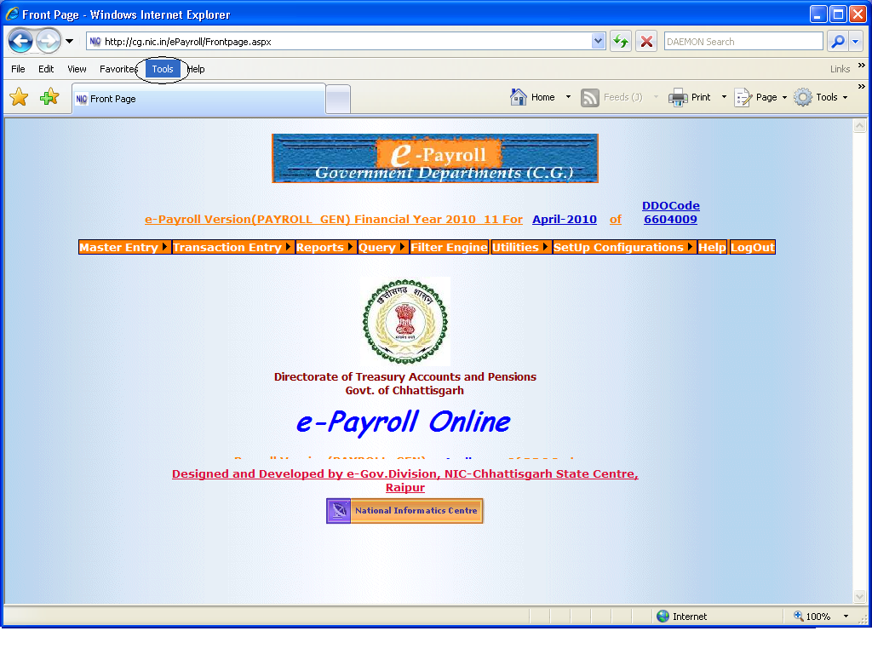
Go to the Tools of Internet explorer.
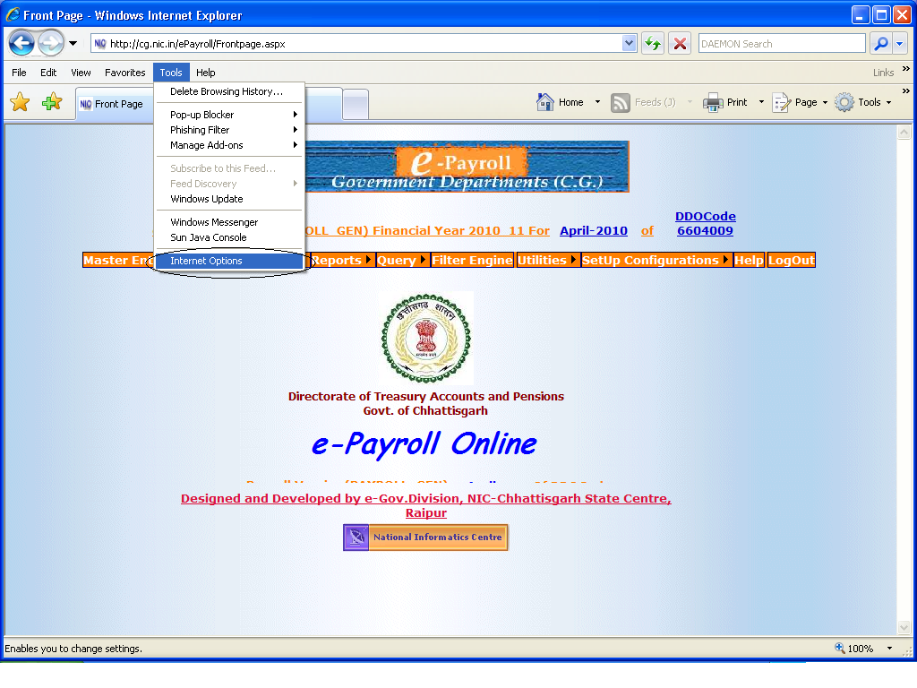
Click on the Internet Option.
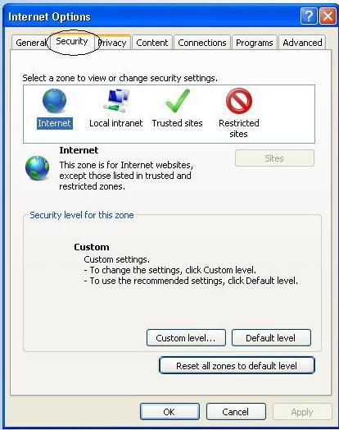
Then go to Security option.
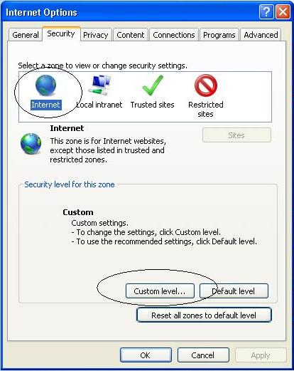

Click on Internet.Then Click on Custom level.
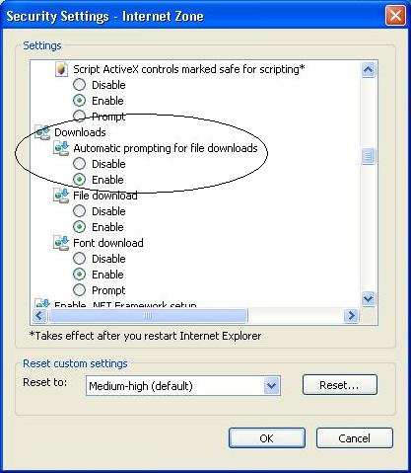

Enable the Automatic prompting for file downloads. After that Your Reports downloading will be start.

